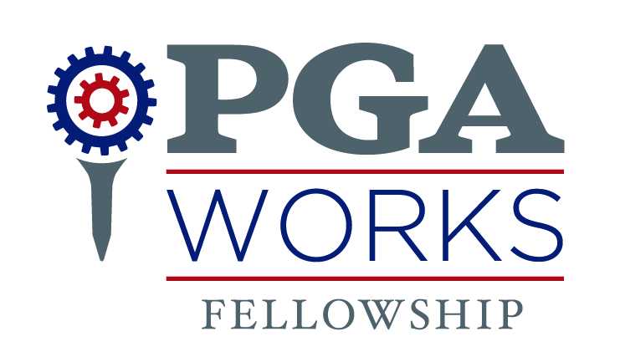

CONNECTICUT PGA SECTION SELECTS
SOFIA ALVAREZ AS PGA WORKS FELLOW
Post-graduate role encourages diversity in the game and business of golf

Editors: For a photo of PGA WORKS Fellow Sofia Alvarez, please click here.

HARTFORD, Conn. (Feb. 11, 2019) — PGA REACH, the 501(c)(3) charitable foundation of the PGA of America — in conjunction with the Connecticut PGA Section — has selected Sofia Alvarez, of Maracaibo, Venezuela, to join the team as a PGA WORKS Fellow. The PGA WORKS Fellowship program aspires to be the most valuable entry-level opportunity for individuals from diverse backgrounds to gain experience in all facets of the golf industry.
In this role, Alvarez will support the mission and purpose of the Connecticut PGA Section Foundation and support PGA HOPE programming, PGA Jr. League, and Drive, Chip & Putt. She will also assist with foundation administration, operations and fundraising events, as related to PGA REACH and the Connecticut PGA Section. Previously, Alvarez served as an intern in the USGA’s P.J. Boatwright Internship Program.
“All career paths start with awareness and opportunity—and providing individuals from diverse backgrounds entry into the golf industry is a priority for PGA REACH,” said Ryan Cannon, Senior Director of PGA REACH. “PGA WORKS is an important initiative, and we’re thrilled to create new possibilities through the PGA WORKS Fellowship to pursue the dream of a career in golf.”
Alvarez earned her Bachelor’s degree in Broadcast Journalism from North Carolina A&T in 2018, graduating Summa Cum Laude, with the highest GPA in her discipline. From 2016-2018, she earned the most valuable player award for the North Carolina A&T women’s golf team, where she competed in the newly renamed PGA WORKS Collegiate Championship (formerly the PGA Minority Collegiate Championship).
“We are thrilled to have Sofia join us,” said Tom Hantke, Connecticut PGA Section Executive Director. “In her role, she will have the opportunity to combine her exemplary education and love of golf to support the Connecticut PGA Section’s commitment to providing opportunities for inclusion within the golf industry.”
Launched in 2017, the PGA WORKS Fellowship now hosts 12 Fellows across the country in the following PGA Sections: Carolinas, Connecticut, Gateway, Metropolitan, Michigan, Middle Atlantic, New Jersey, Northern Ohio, Southern Ohio, Western New York, Indiana and South Florida. The goal is to have Fellows in all 41 PGA Sections.
“I see myself as serving as a bridge for the PGA of America to develop inclusion in the golf industry, as well as expand cultural horizons,” said Alvarez. “I look forward to combining my passion for golf and education to serve as a role model in this fellowship role with the Connecticut PGA Section.”
The PGA of America recognizes that it will be defined by how its commitment to diversity and inclusion resonates throughout its programs and practices. This commitment is mission critical to the health and relevance of the business and the game overall.
For more information on PGA REACH, visit pgareach.org.

About PGA WORKS
PGA WORKS is the umbrella brand for all workforce diversification programs that are part of the PGA of America’s commitment to diversity and inclusion, one of the organization’s foundational principles. PGA WORKS is an intentional effort to evolve the demographic composition of the golf industry’s workforce through a variety of programmatic efforts, including leadership development, fellowships, internships, scholarships, the PGA WORKS Career Expo and PGA WORKS Collegiate Championship. PGA WORKS programs are designed to appeal to, recruit and retain diverse talent who are prepared to ascend into key employment positions across all lines of business within the golf industry and specifically the PGA of America. For more information visit, pgareach.org.

About PGA REACH
PGA REACH is the 501(c)(3) charitable foundation of the PGA of America. The mission of PGA REACH is to positively impact the lives of youth, military and diverse populations by enabling access to PGA Professionals, PGA Sections and the game of golf.

About the PGA of America
The PGA of America is one of the world’s largest sports organizations, composed of PGA Professionals who daily work to grow interest and participation in the game of golf. For more information about the PGA of America, visit PGA.org, follow @PGA on Twitter, and find us on Facebook.

Contact:
Michael Abramowitz PGA of America mabramowitz@pgahq.com 561/624-8458
Chelsea Hellems Dixon Schwabl Chelsea_Hellems@dixonschwabl.com 585/899-3244
Tom Hantke Connecticut PGA Section thantke@pgahq.com 860/430-2302
###

